**Phase 1:** **Requirement Gathering**

* **Input of Stakeholder:**  
  The goal is a tool for *individuals and teams* to define habits/goals (such as “Exercise daily”, “Read weekly”) and track progress with ease, visibility, and motivation.
* **Critical requirements:**
  + Custom habit creation (fields: Name, Category, Goal, Points).
  + Habit logging with completion date and notes.
  + Statistics: streaks, totals (7/30 days), last completion, points.
  + Preventing duplicate logs for same habit/date.
  + Reminders for missed habits; congratulatory messages for milestones.
  + Mobile accessibility and quick actions for rapid logging.
  + Multi-user support (if scaling for organizations) for managers to review team wellness and engagement.
  + Security: each user sees only their own data unless managing a team.

**Formalized user stories:**

* + “As an individual, I want to easily log habit completions and view my streaks so I stay motivated.”
  + “As a manager, I want to see team habit statistics for group wellness programs.”
  + “As a user, I want reminders if I miss a habit several days in a row.”
  + “As an admin, I want automated roll-ups and process enforcement for data integrity.”

**Stakeholder Analysis**

* **Project Lead & End User:** Guide requirements and priorities—wanting an app that is simple yet powerful, with meaningful visuals and actionable feedback.
* **IT/Admin Team:** Ensures technical stability, data privacy, user access (sharing rules, security).
* **Managers:** Interested in aggregate reports, engagement trends across users/groups.
* **Salesforce Developers:** Responsible for object configuration, automation (triggers, flows), and LWC development.
* **Champion Users:** Early adopters that provide feedback on usability and feature gaps.

**Business Process Mapping: Habit & Goals Tracker**

**Process Steps**

1. **User Creates New Habit**
   * Enters Habit Name, Category (e.g., Health, Learning), Daily Goal, Points per Completion.
   * Saves Habit record.
2. **User Logs Habit Completion**
   * Selects Habit from list.
   * Enters Completion Date and optional Notes.
   * Submits HabitLog record.
3. **System Validates & Updates Stats** (via Apex Trigger / Process)
   * Checks for duplicate logs for same habit and date to enforce uniqueness.
   * Updates parent Habit fields (e.g., increments total completions, recalculates current streak, updates Last Done Date).
   * Awards points based on completion.
4. **System Sends Notifications**
   * If a habit is missed for X days (configurable), sends reminder email or Chatter notification.
   * Upon reaching milestones (e.g., 7-day streak), sends congratulatory messages.
5. **Users and Managers View Dashboards**
   * Displays habit list with categories, streaks, totals for last 7/30 days.
   * Displays charts (bar, timeline) showing progress and points earned.
   * Managers can view aggregated data for their team or group.
6. **Admins Audit & Monitor**
   * Audit habit logs for anomalies or data issues.
   * Identify inactive habits and optionally flag or archive them.
   * Manage user access and sharing rules for data confidentiality.
7. **End of Process**

**Flowchart Visualization (Linear with feedback loops)**

Start → [Create Habit] → [Log Completion] → [Validate & Update Stats] →  
   → [Send Notifications] → [View Dashboard/Reports] → [Admin Audit] → End

* Feedback loops:
  + From **Notifications** back to Users to encourage logging.
  + From **Dashboard** to User or Manager for ongoing engagement.
  + Admin audit may trigger data corrections or user communication.

This detailed process and flowchart offer a clear guide for system design, development, and testing phases, ensuring all user interactions and backend automations are properly orchestrated.

**Industry-specific Use Case Analysis**

* **Industry Needs:**
  + Personal productivity: health, learning, wellness, behaviors.
  + Enterprise wellness: tracking participation in group goals, campaigns, rewards.
  + Key features: custom habits, analytics, gamification, reminders, mobile optimization.
  + Market gaps: Most Salesforce productivity and status tracker apps focus on business processes; few support flexible, personalized habit tracking with points, streaks, and engagement visualization.

**AppExchange Exploration**

* **Research Summary:**
  + Popular productivity apps (Rollup Helper, Status Tracker, Adoption Tracker) address data roll-ups, sales process milestones, and engagement analytics—but not habit-centric workflows.
  + No direct AppExchange solution for “personal or team habit tracking with customizable logic, gamification, or mobile-first rapid logging”.
  + This project fills a distinct gap: user-defined habits, rich visual statistics, rewards/notifications—all integrated into Salesforce Lightning UI.

**Phase 2: Org Setup & Configuration**

* + 1. **Salesforce Edition:-**

Used Developer Edition (Free Dev Org) for design, testing, and prototyping.

* + 1. **Company Profile Setup**
* T**ask:** Enter organizational details.
* **Action:**
* Setup → **Company Information** → Fill in company name, address, phone, currency locale.
* Configure default currency (INR/USD).
* **Why:** Ensures consistent branding and localization.

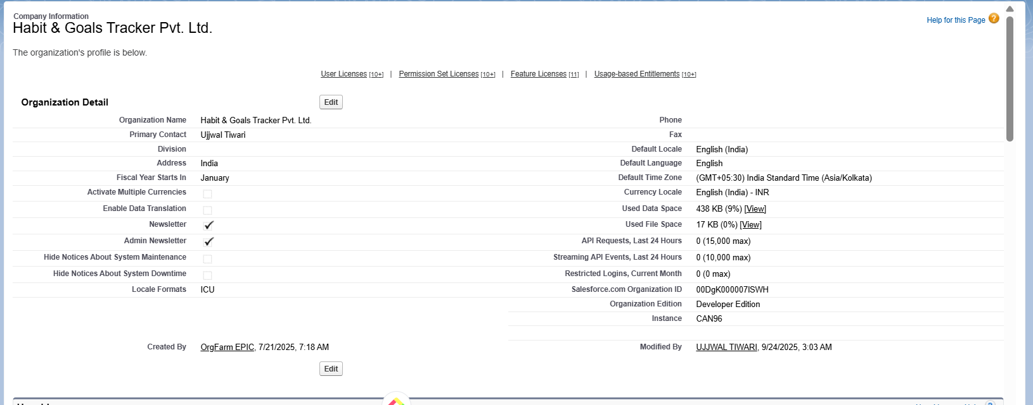

* + 1. **Business Hours & Holidays**

**A. Business Hours Setup**

- The days and hours that your support team is available. These hours, when associated with escalation rules, determine the times at which cases can escalate.

- Kept it default

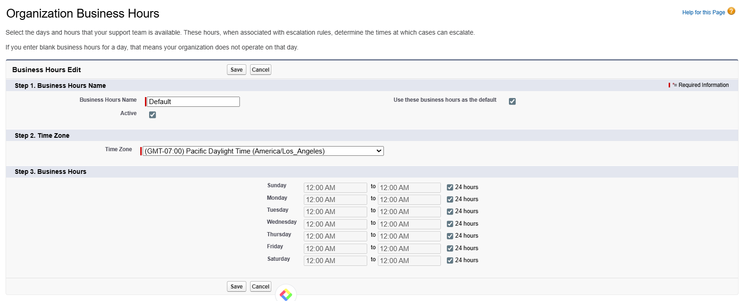

**B. Holidays Setup**

Holidays are dates and times at which business hours are suspended. Business hours are the days and hours that your support team is available.

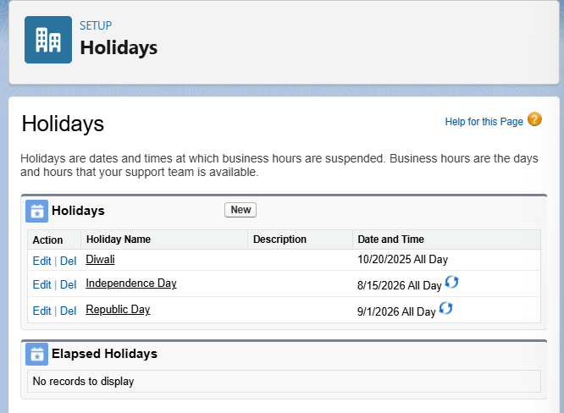

* + 1. **Fiscal Year Settings**

A standard fiscal year (January to December) is used to support revenue tracking, maintenance planning, and operational reporting.

* + 1. **User Setup & Licenses**

**User 1: Admin User (you)**

* First Name: UJJWAL
* Last Name: TIWARI
* User License: Salesforce
* Profile: **System Administrator**
* Role: **Admin**

**User 2: Manager User**

* First Name: Manager
* Last Name: User
* User License: Salesforce
* Profile: **Manager Profile** (the one you cloned/customized earlier)
* Role: **Manager** (your custom role)

• **Normal End User:** Can create and view only their own habits/logs.

* Profile: Custom End User Profile
* Role: End User (lowest level)
  + 1. **Profiles**

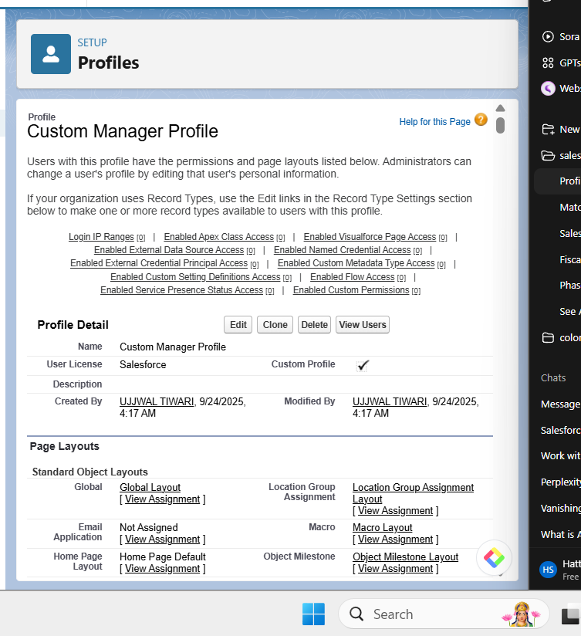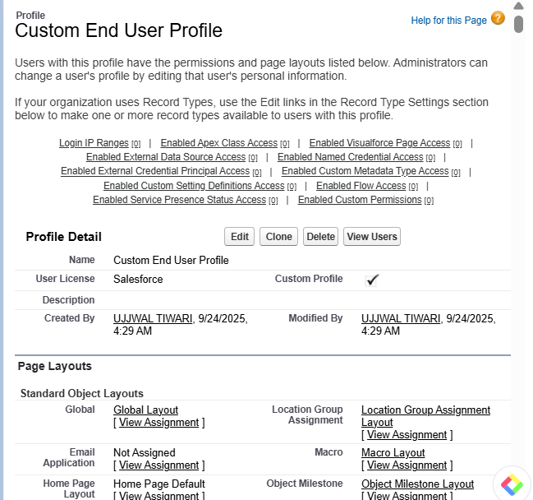

**“Profile Permissions Pending”**

* + 1. **Roles**

**Goal:** Build a role hierarchy in Salesforce so users see only the data they’re supposed to, while managers/admins can see team or organization-level data. This ensures proper **record visibility** for multi-user habit tracking.

**Admin (top)**

**└── Manager**

**└── End User**

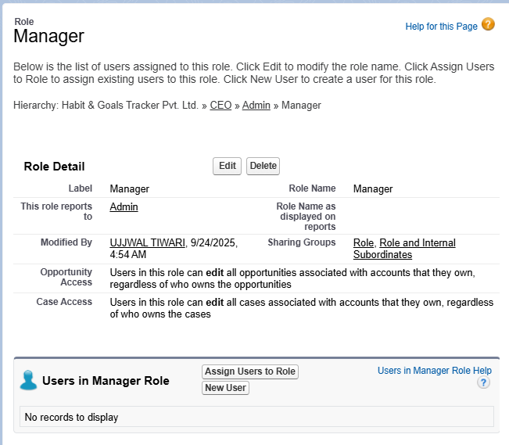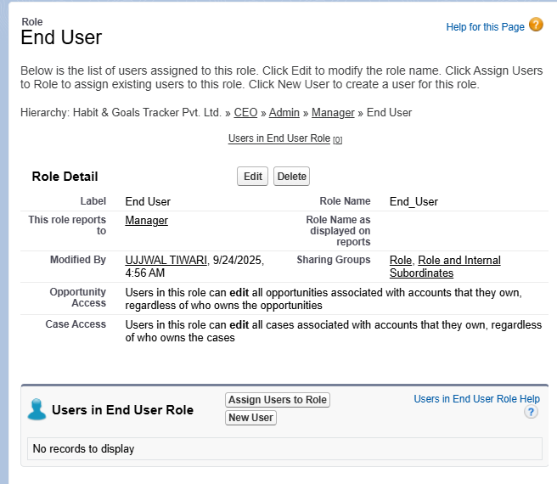

* + 1. **Permission Sets**

## **8.1: Habit Tracker Extra Access**

**Label:** Habit Tracker Extra Access  
**API Name:** Habit_Tracker_Extra_Access  
**User License:** Leave as None

➡️ Inside the Permission Set → **System Permissions → Edit** → enable only:

* ✅ **API Enabled** → required for integration/API testing.
* ✅ **View Reports in Public Folders** → allows Managers/End Users to run and see reports you build for Habit & HabitLog.

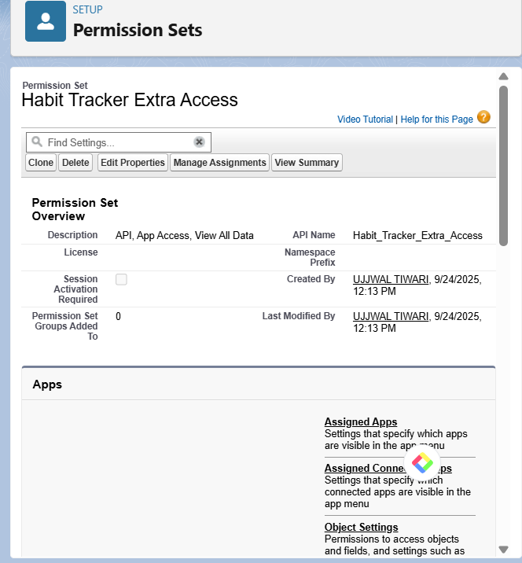

**8.2: Habit Report Access**

1. **Label:** Habit Report Access
2. **API Name:** Habit_Report_Access
3. **User License:** Leave as None
4. Save

➡️ Inside Permission Set → **System Permissions → Edit**:

* ✅ Run Reports
* ✅ Export Reports
* ✅ View Reports in Public Folders

Click **Save**.

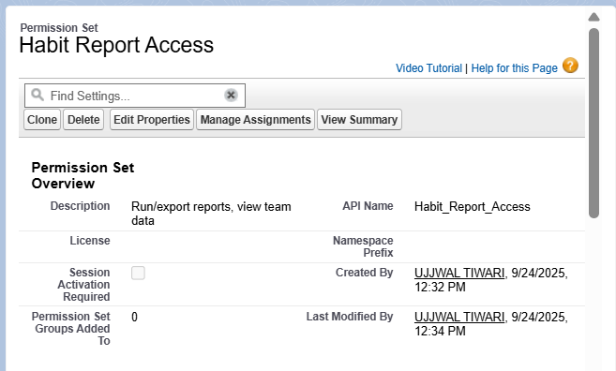

**8.3: Create “Admin Integration Access” Permission Set**

1. From Permission Sets → click **New**.
2. **Label:** Admin Integration Access
3. **API Name:** Admin_Integration_Access
4. **User License:** Leave as **None**.
5. Click **Save**.

➡️ Inside this Permission Set:

1. Go to **System Permissions → Edit**.
2. Check:
   * ✅ API Enabled
   * ✅ Modify All Data
3. Save.

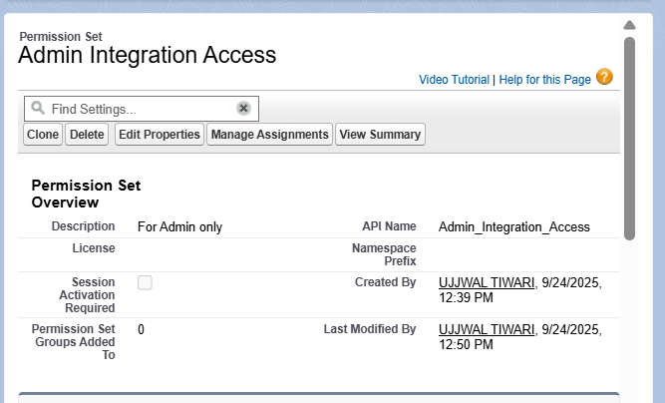

**8.4: (Optional) Create “Temporary Feature Access”**

1. Permission Sets → **New**.
2. **Label:** Temporary Feature Access
3. **User License:** Leave as **None**.
4. Save.

➡️ Later, when we add **Custom Permissions** (for AI suggestions, notifications, etc.), add them here.

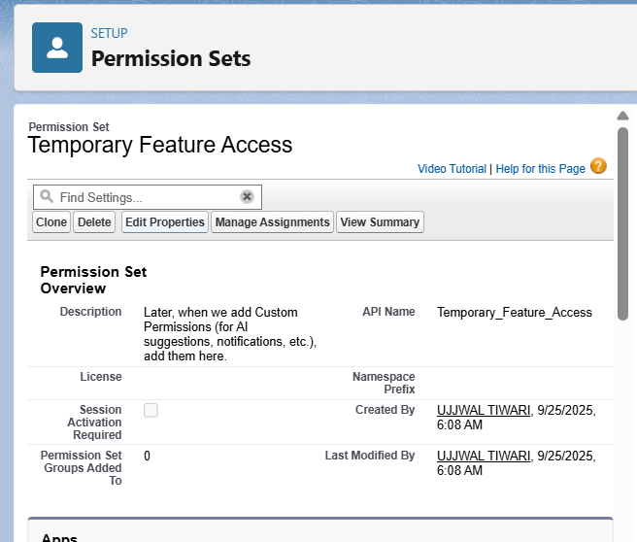

* + 1. **OWD**
    2. **Sharing Rules**
    3. **Login Access Policies**
    4. **Dev Org Setup**
    5. **Sandbox Usage**
    6. **Deployment Basics**